**Ram sai kiran chintala**

**12594885**

**Assignment 1 makeup**

Question 2:

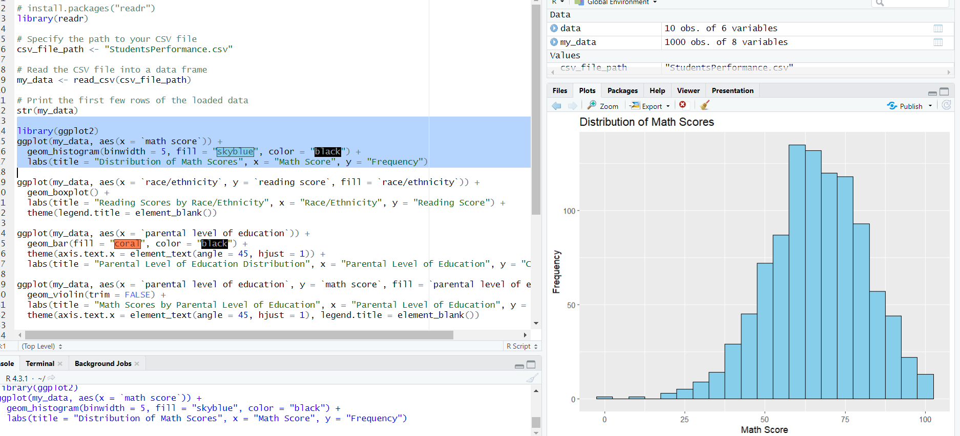

Histogram of Math Scores:

Visualizes the distribution of math scores among students, showing the frequency of scores in bins of width 5.

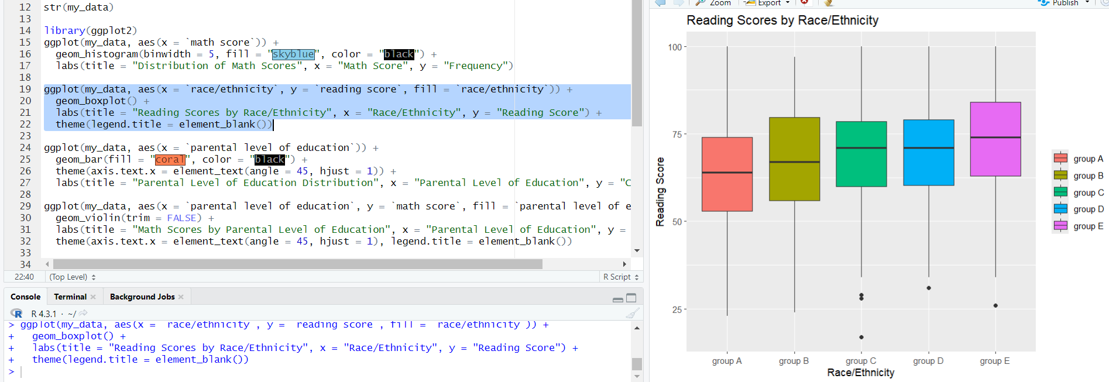

Boxplot of Reading Scores by Race/Ethnicity:

Illustrates the spread and central tendency of reading scores across different race/ethnicity groups through boxplots.

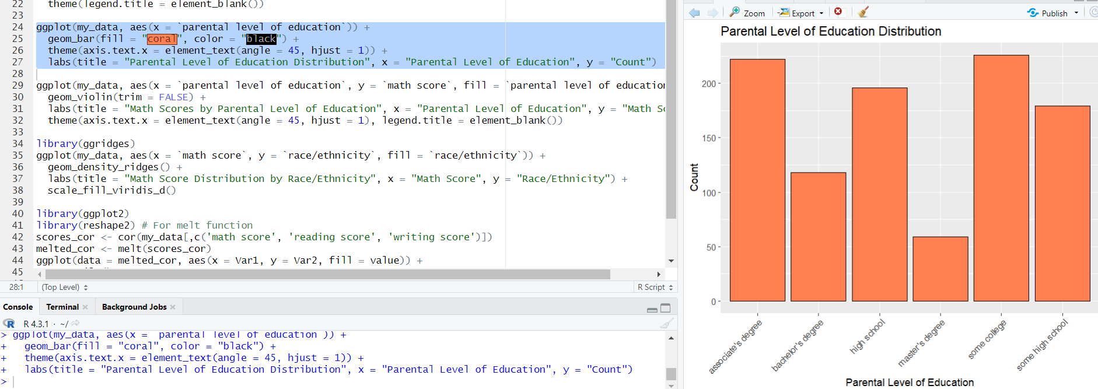

Bar Chart of Parental Education Distribution:

Displays the count of students based on their parents' levels of education, providing an overview of the distribution.

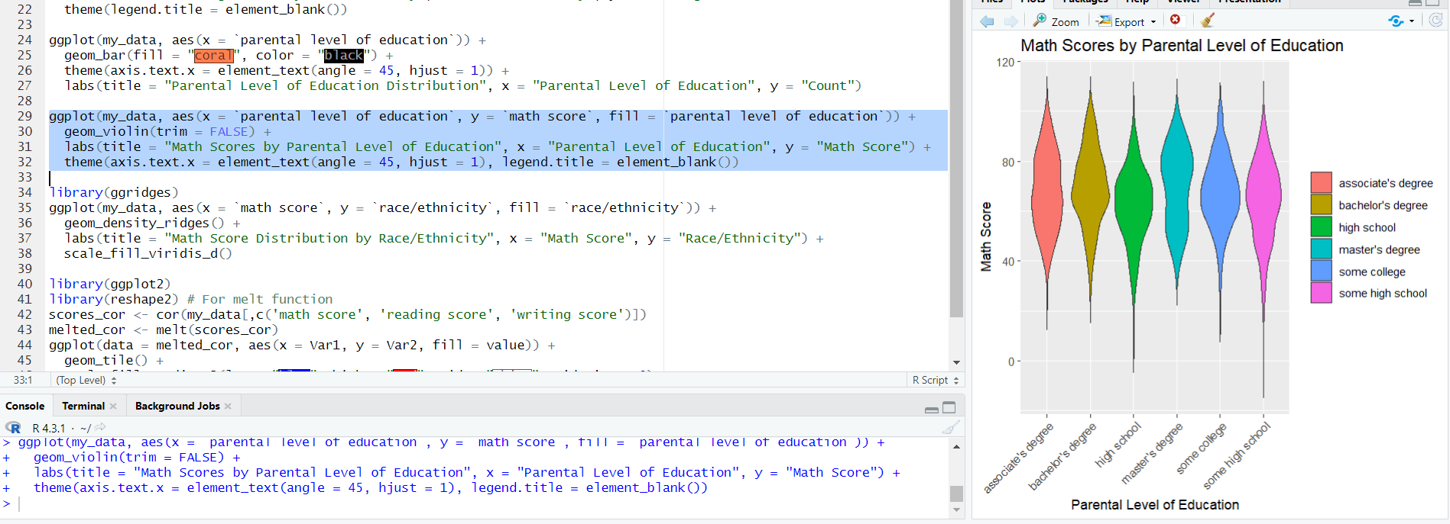

Violin Plot of Math Scores by Parental Education:

Depicts the distribution of math scores across parental education levels using violin plots, showcasing the data's density.

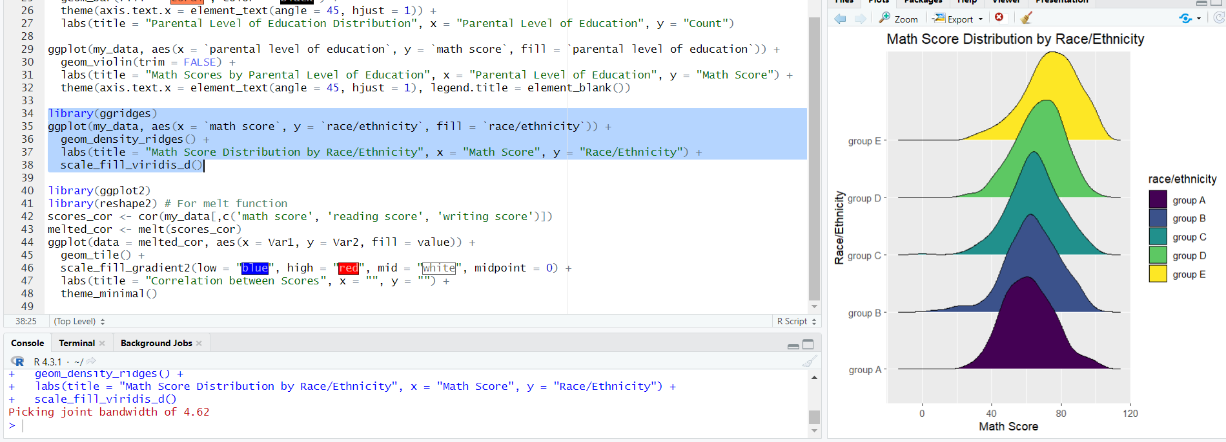

Density Ridges of Math Scores by Race/Ethnicity:

Represents the density of math scores by race/ethnicity, highlighting the distribution patterns for each group.

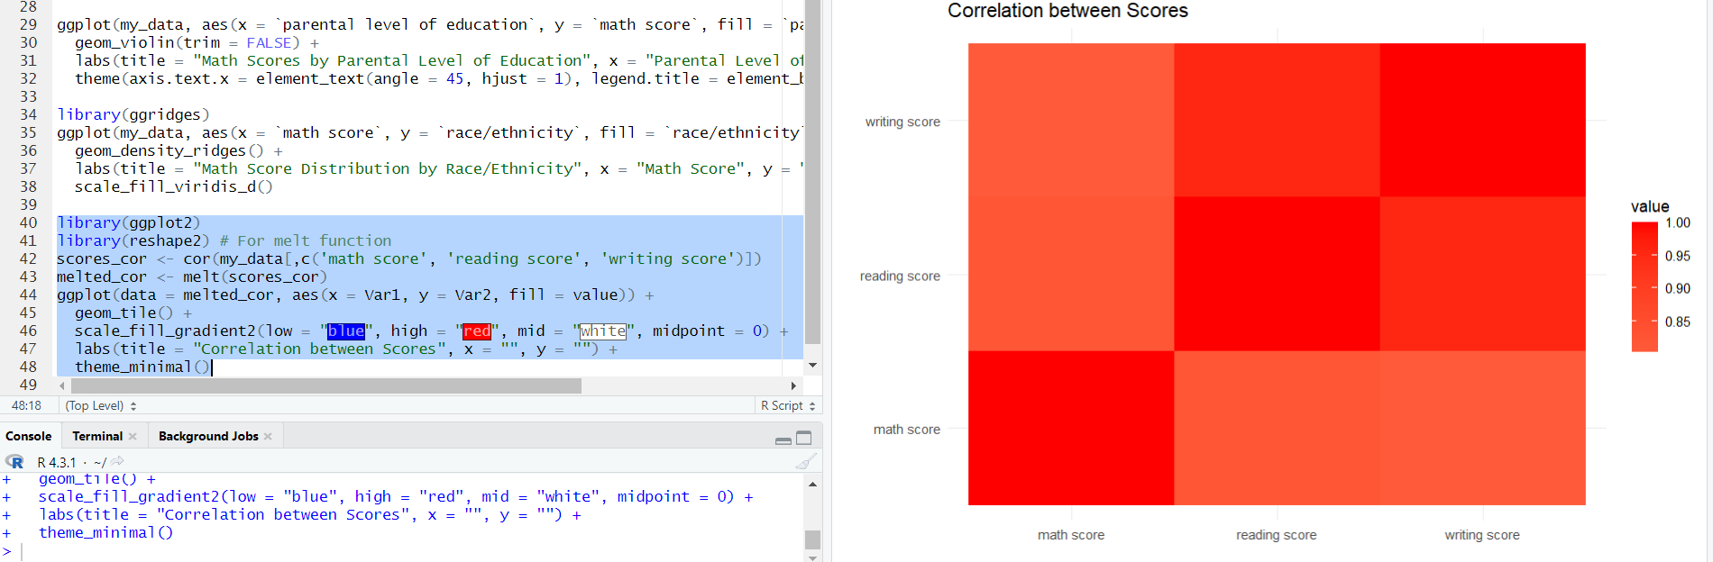

Correlation Heatmap of Exam Scores:

The correlation matrix between math, reading, and writing scores, using a gradient heatmap with blue, white, and red colors to indicate strength and direction of correlations.